PLESSO FABRIANO

CLASSE 5A

GEOGRAFIA
---Ripassare le regioni dell’Italia meridionale.
---Studiare Molise e Puglia
---Svolgere gli esercizi sul quaderno operativo
https://www.youtube.com/watch?v=kFZQOX7k0sw
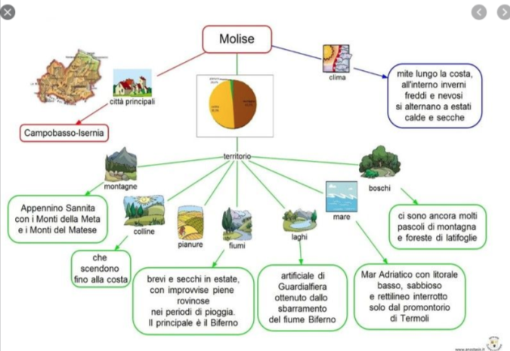
https://www.youtube.com/watch?v=i-1_CeKtDIc

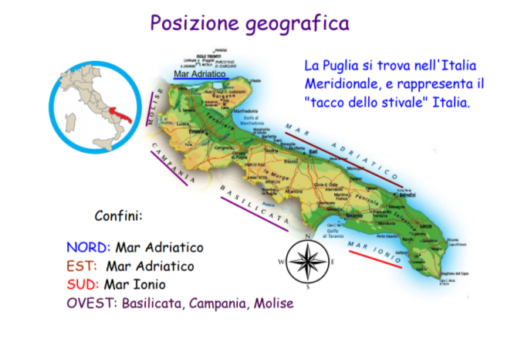
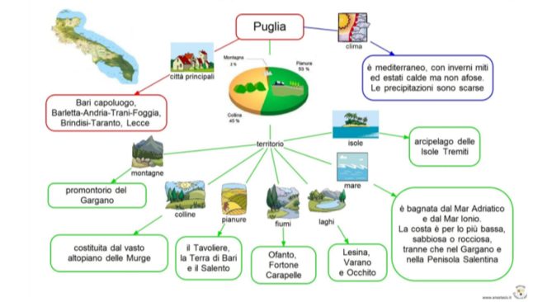
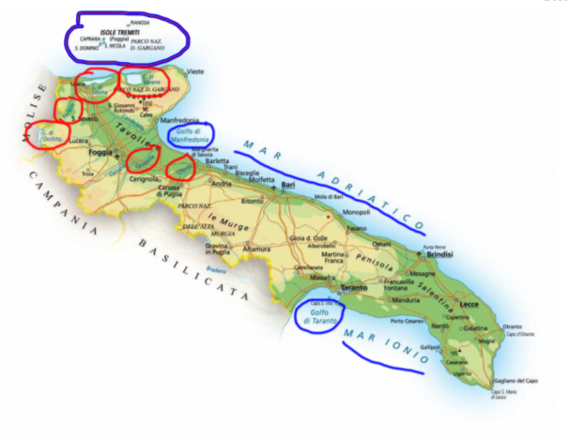
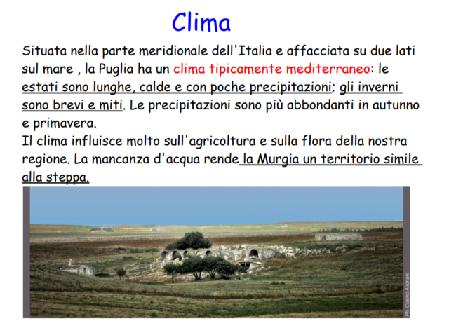
https://www.youtube.com/watch?v=wF2SrWlCb8M

https://www.youtube.com/watch?v=x7DxxyXwyEs

STORIA
--Ripassare le mappe concettuali dei persiani e dei macedoni
--Lavorare sulle schede operative dei greci
https://www.youtube.com/watch?v=yf9kb64zs8g
https://www.youtube.com/watch?v=dZ0IbYcOVLs
https://www.youtube.com/watch?v=6p22RR-_dDI
https://www.youtube.com/watch?v=E6U-Mj2D20M
https://www.youtube.com/watch?v=gnCNtpv8Eyk
https://www.youtube.com/watch?v=eHEevCmn75k

ITALIANO
--Gli attributi
https://www.youtube.com/watch?v=sp2P5qDVJ9I
https://www.youtube.com/watch?v=b1yUy-MnlAU
--Ripassare il verbo essere e avere
https://www.youtube.com/watch?v=ep1v06sSye8
https://www.youtube.com/watch?v=G-0Q_5YcaOM
https://www.youtube.com/watch?v=fAl6QZXV8ps
https://www.youtube.com/watch?v=8-FyohoQ6o0&t=64s
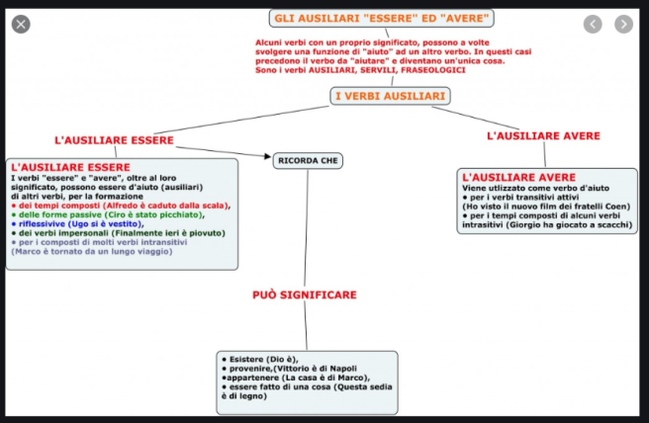

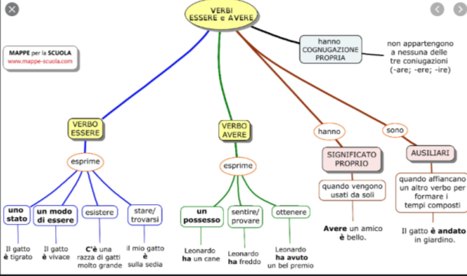
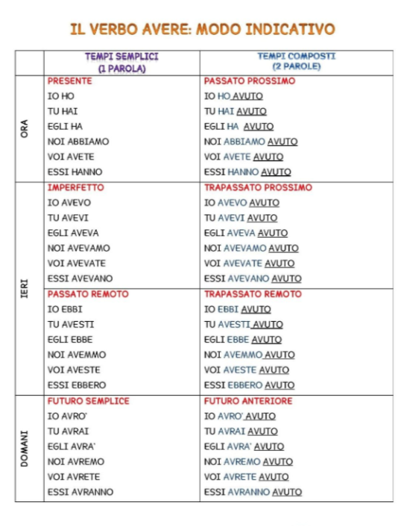
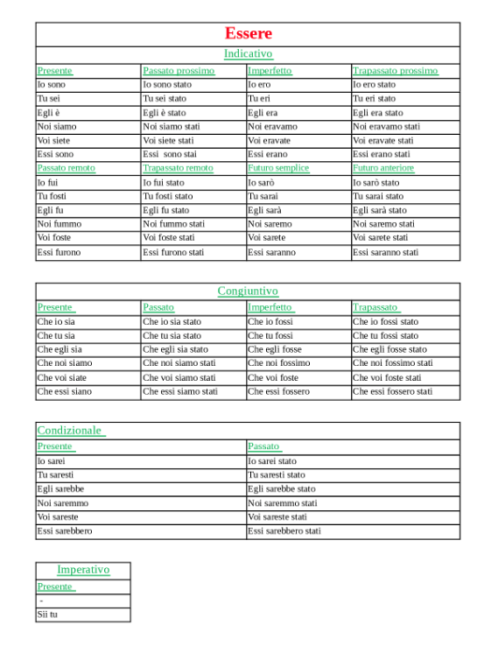
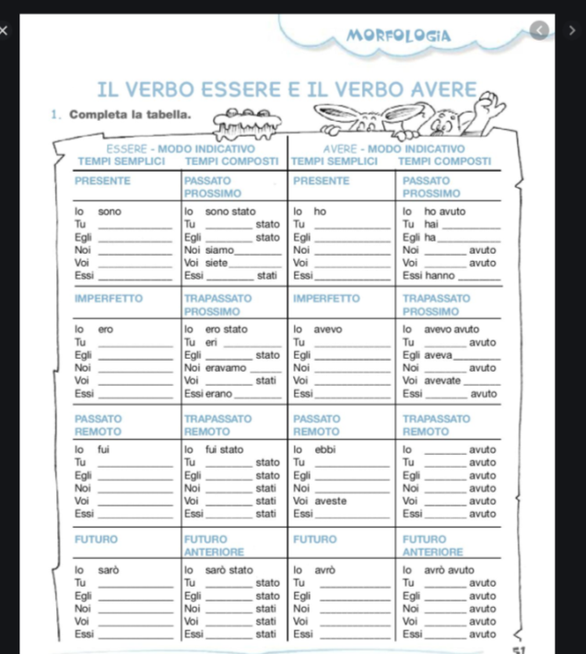
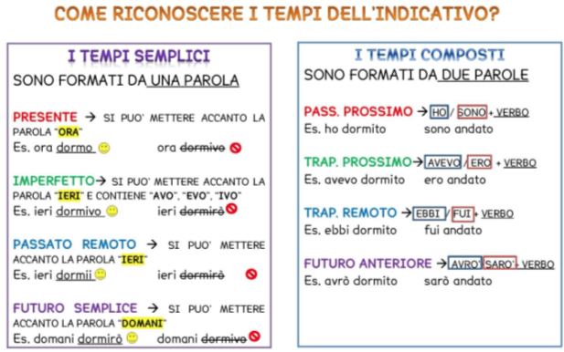

MATEMATICA E GEOMETRIA
https://www.youtube.com/watch?v=2cV_DjDdDzI
https://www.youtube.com/watch?v=RiMUlrWELEk
https://www.youtube.com/watch?v=6kvcdlUMKu4

